Program 1: VHDL Code for Full Adder
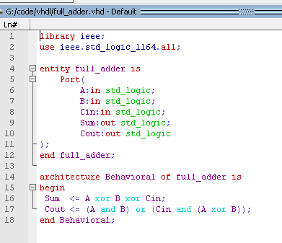

Program 2: VHDL Code for 16-bit Ripple Carry Adder (RCA)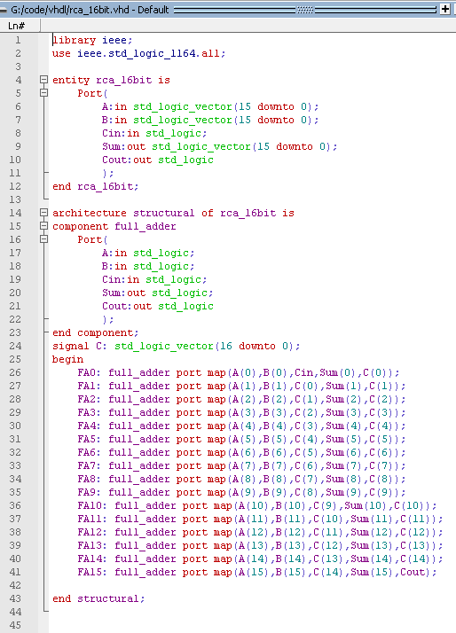
Program 3: VHDL Code for 16-bit ALU
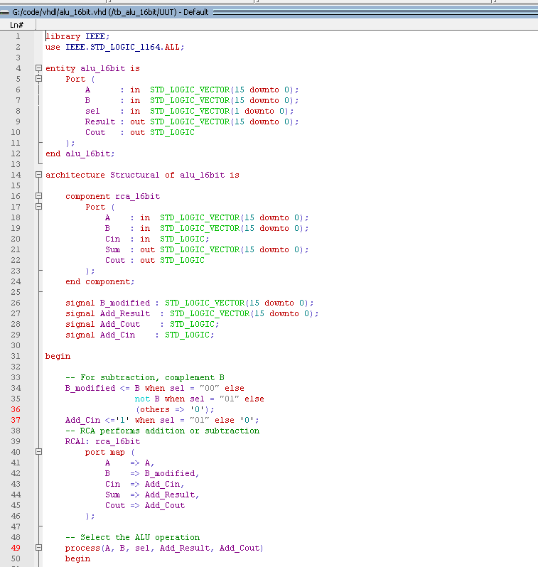
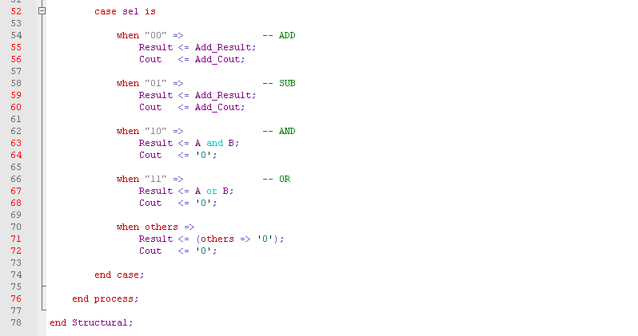
Program 4: VHDL Testbench Code for 16-bit ALU
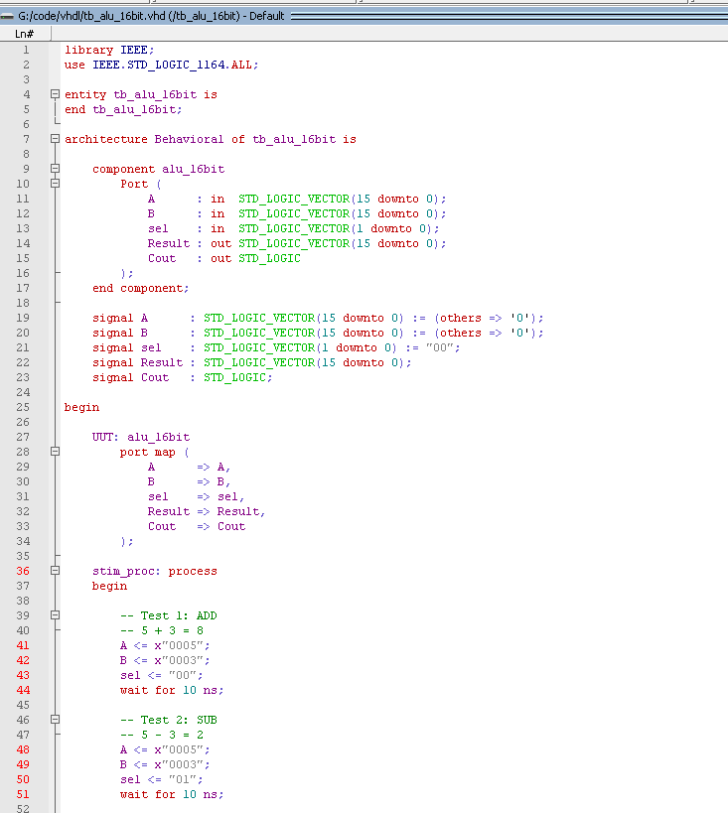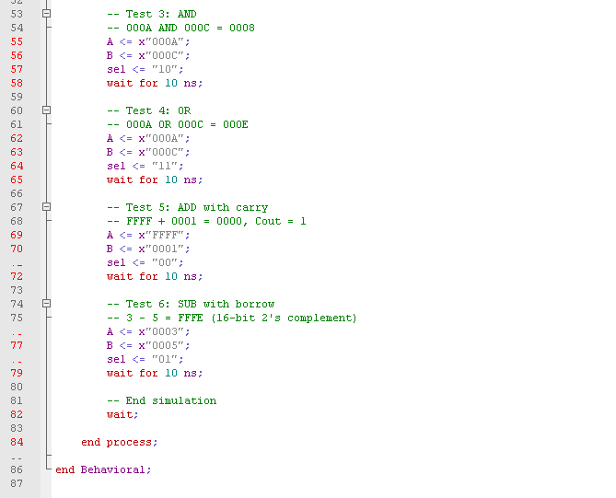
Testbench Output: 16-bit ALU Simulation Results
